**WorkSheet:- 3.2**

**Student Name:** Vivek Kumar **UID:** 21BCS8129

**Branch:** BE-CSE (LEET) **Section/Group:** 20BCS-809/A

**Semester:** 4th Sem **Date of Performance:** 20/04/2022

**Subject Name:** SE Lab **Subject Code:** 20CSP-255

**AIM: - Design a structure chart for a ticket vending machine at a metro station.**

**Requirement Analysis:**

**Software Requirement**

* Windows10 / Mac-OS
* Chrome/Firefox/Safari Browser
* App.diagrams.net website

**Hardware requirement**

* + Computer / laptop
  + Power supply

**Solution: -** **Structure Chart** represent hierarchical structure of modules. It breaks down the entire system into lowest functional modules, describe functions and sub-functions of each module of a system to a greater detail. Structure Chart partitions the system into black boxes (functionality of the system is known to the users but inner details are unknown). Inputs are given to the black boxes and appropriate outputs are generated.

Modules at top level called modules at low level. Components are read from top to bottom and left to right. When a module calls another, it views the called module as black box, passing required parameters and receiving results.

**Structure Chart:**

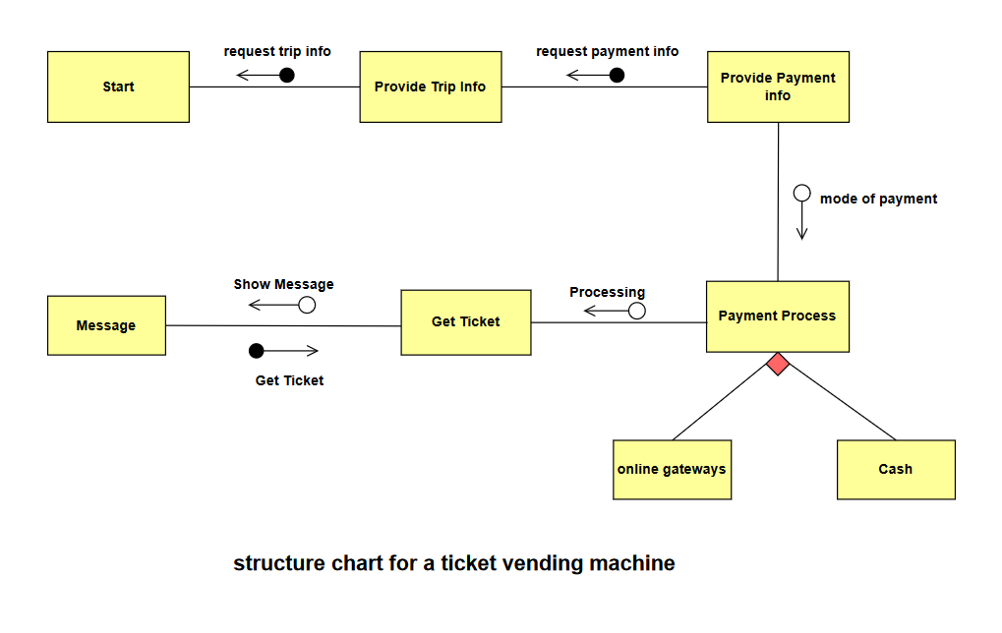

**Description:** A **ticket machine**, also known as a **ticket vending machine (TVM)**, is a vending machine that produces paper or electronic tickets, or recharges a stored-value card or smart card or the user's mobile wallet, typically on a smartphone. For instance, ticket machines dispense train tickets at railway stations, transit tickets at metro stations and tram tickets at some tram stops and in some trams.  **Token machines** may dispense the ticket in the form of a token which has the same function as a paper or electronic ticket. The typical transaction consists of a user using the display interface to select the type and quantity of tickets and then choosing a payment method of either cash, credit/debit card or smartcard. The ticket(s) are then printed on paper and dispensed to the user, or loaded onto the user's smartcard or smartphone.

**Evaluation Grid (To be created as per the SOP and Assessment guidelines by the faculty):**

|  |  |  |  |
| --- | --- | --- | --- |
| Sr. No. | Parameters | Marks Obtained | Maximum Marks |
| 1. |  |  |  |
| 2. |  |  |  |
| 3. |  |  |  |
| 4. |  |  |  |